



**3rd Quarter Newsletter July-September, 2020**

 Hello Southpoint Owners,

I hope this message finds you and your family safe and well, and enjoying the rest of your summer!

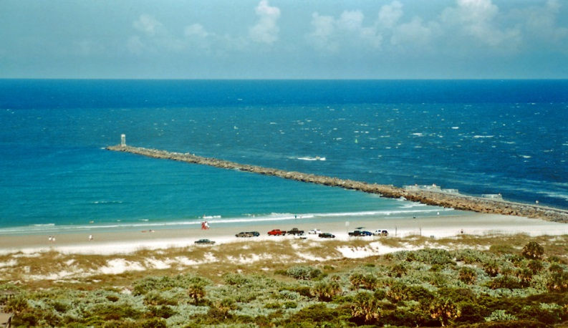

Per Roger Koop, the following improvements have recently been made at Southpoint –

1. Roger will post weekly engineering reports to go with the ongoing reports located for your viewing pleasure on the Southpoint website under the Documents tab. You will also see photographs of the progress being made.
2. Window replacement has begun! The office now has new windows.



Please remember that SPC is still an active construction zone. Currently the South side of the building is under construction and is considered closed except for contractors. If you must be in your unit (for updating), please use extreme caution. Renters are not at all allowed in the closed sections of the building. Children are *never* allowed in an active construction site. No exceptions.



Let’s meet Southpoint owners!

Meet Janine Brancale, owner of #303, pictured below with husband Patrick and her parents.

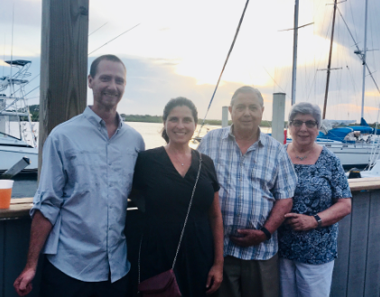

My Grandparents moved to Ponce Harbor (directly across the street from Southpoint) when I was a little girl. In fact, Southpoint had not been built yet! I have spent time in Ponce Inlet, on a yearly basis, my whole life. In 2018 I was sitting on the beach browsing on Zillow and there were a couple of units for sale. Pretty much on a whim I decided to look at unit 303 and put an offer on it. My parents split their time between Connecticut and Ponce so it all made sense to have a second home here. I love Ponce Inlet, you could say it is my happy place.

We live in Connecticut and while planning our

wedding last year Patrick and I looked around in

Connecticut for a venue for our wedding. Ultimately Ponce Inlet was where we wanted to have our big day. The wedding was scheduled for April 18th at the Wilbur Boathouse. Sadly, we had to postpone due to COVID-19. We ended up having a Zoom wedding, in our living room, and some of our Southpoint friends were able to attend. We look forward to rescheduling after the window installation and construction is completed.

Our wedding was featured on Good Day NY which was fun. Here is a link to the spot: <https://youtu.be/bfGgDW_q3Zw>

When I am not sitting on the beach in Florida I run a car dealership in Connecticut. We spend our free time hiking, fishing and paddling.

If you would like to be in the Owner Spotlight, send your story and some information with a picture to: Linda Collette at [redcar@charter.net](mailto:redcar@charter.net)

Next up: Beach Safety

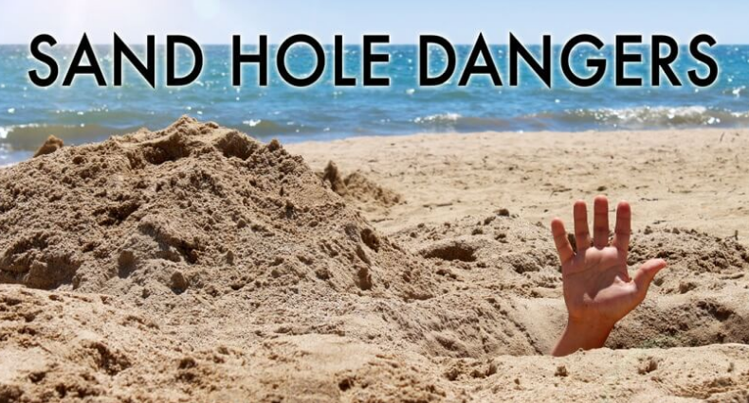

When people are at the beach, their biggest concern is the ocean. They’ve heard of rip currents and deep water, sharks and jellyfish, but most of them have never heard or thought about the dangers of digging in the sand.

The most obvious concern is **that people and animals can fall into holes**. This often happens to bike riders or nighttime beachgoers who are stargazing or searching for crabs with flashlights.

Another group largely affected by holes on the beach are the lifeguards. Any vehicle on the beach is in danger of getting stuck in a hole, but the ocean rescue guards are on the beach every day and sometimes at night making sure that everyone is safe. Their four-wheeler and truck wheels can get wedged into holes, sometimes damaging the vehicles and equipment to the point where the lifeguard can no longer respond to a call.

**The greater danger of digging is that the sand will collapse on someone.** Unlike dirt and clay, sand is unstable and is known for collapsing without warning.  It also tends to replace itself as soon as it is scooped away. When a hole collapses on someone, it usually leaves no trace of the buried victim, which can make rescue efforts difficult because rescuers do not always know where to dig and cannot use any heavy equipment.

**Luckily, accidents like this can be avoided by following some simple rules:**

###### **• Never dig a hole deeper than the knees of the smallest person in the group** **• No tunneling whatsoever** **• Always fill in holes when you leave the beach**

Please think of others when you are digging holes, and fill them in before you leave that day.

This is not to say that you cannot cover someone in sand for a humorous picture. Just follow our tips for staying safe, and you will have a great time.  Maybe opt for a sand castle or sand art instead of digging a deep hole. There are plenty of ways to enjoy yourself at the beach.

Sea turtles are already at risk, and without even realizing it, thousands of beachgoers are making it even harder for them to survive. Every time someone digs a hole in the sand and doesn't fill it in or builds a sand castle and leaves it behind, they are putting sea turtle lives in danger. It may not sound like much, but digging wide and deep holes at the beach during sea turtle nesting season can expose a buried nest that has not yet been marked with stakes, putting those eggs in jeopardy. Marine researchers have reported a steep increase in the number of man-made holes across our beaches this summer.

The local beaches Sea Turtle Patrol has been trying to spread the word about the danger of digging holes.

Nobody needs to be digging a hole 8 feet by 4 feet,

the bigger and deeper the hole, the bigger the threat.

If a nesting female gets caught in one of these holes, she’s done. Turtle Patrol observers don’t think it’s as much our young adults as it is our older adults digging holes as they see all kinds of crazy things like building a beach couch.

As long as you return the sand to normal before you leave you can build in the sand, otherwise leaving holes can obstruct the path for hatchlings trying to make it to sea. When those little guys take off out of the nest they would never get out of a hole that’s two to four feet deep and wide.

On average only one in 5,000 hatchlings actually make it to adulthood, according to the Marine Life organization, that's why protecting them as much as possible is so important.

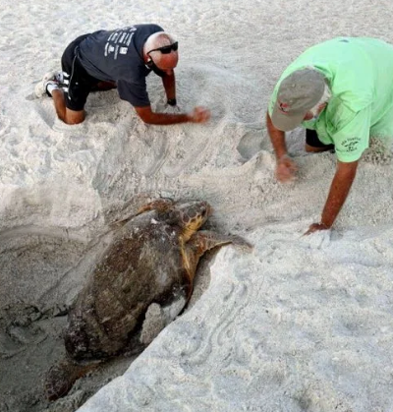

Turtle season is May 1 to November 1, please remember that it’s “lights out” at night during this time. Close your blinds on windows and doors that face the beach.

So please be kind, don’t dig big deep holes, and before you leave the beach, make sure you leave sand as it should be and remember to throw away your trash and recyclables in the correct trash barrels.

Let’s leave the beach better than we found it!



Owner Kevin Bailey has

created an e-mail list with owners names, unit #, e-mail address, telephone number and rental agency if you rent. If you’d like to be added to this list, please contact Kevin with your information at [kevinbail@bellsouth.net](mailto:kevinbail@bellsouth.net) and he’ll add you.



Owners, find our Owners Only SPC Facebook page and join. It’s called Southpoint Condominiums Owners. We share pictures, local information and goings-on, etc.

**Note: The 2020 Annual Board Meetings are set for Saturday, December 5th!**

If you have any newsworthy information you’d like to see here, pictures, etc., please share it with us. You may send any information to Linda Collette via e-mail to: [redcar@charter.net](mailto:redcar@charter.net), and please put “SPC Newsletter” in the subject line. Thank you!

**Southpoint Condominium Association Board of Directors:**

Phil Danley, President - [phil.danley@gmail.com](http://mailto:phil.danley@gmail.com/)

Alan Powell, Vice-President - [adp5721@comcast.net](http://mailto:adp5721@comcast.net/)  
Judy Voiers, Secretary/Treas.  [jvoiers@tampabay.rr.com](http://mailto:jvoiers@tampabay.rr.com/)

Management Company: TJW Management Co, Inc.

Roger Koop, Manager and Maintenance Supervisor, 386-788-4546--[roger.koop@gmail.com](mailto:roger.koop@gmail.com) Karen Stewart - General Manager- kstewart@tjw.net